**Exercise 3: Stored Procedures  
  
Scenario 1:**

**Table Creation**CREATE TABLE SavingsAccount (

AccountID NUMBER PRIMARY KEY,

CustomerName VARCHAR2(100),

Balance NUMBER

);

**INSERT VALUES**

INSERT INTO SavingsAccount VALUES (1, 'Anu', 1000);

INSERT INTO SavingsAccount VALUES (2, 'Jo', 2000);

INSERT INTO SavingsAccount VALUES (3, 'Rejith', 3000);

COMMIT;  
  
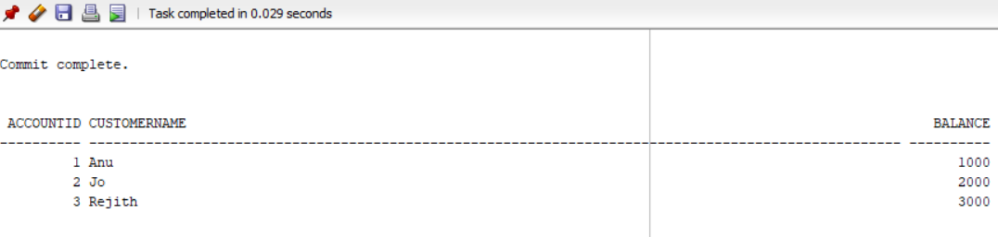

CREATE OR REPLACE PROCEDURE ProcessMonthlyInterest IS

BEGIN

FOR rec IN (SELECT AccountID, Balance FROM SavingsAccount) LOOP

UPDATE SavingsAccount

SET Balance = Balance + (Balance * 0.01)

WHERE AccountID = rec.AccountID;

END LOOP;

COMMIT;

END;

EXEC ProcessMonthlyInterest;

**OUTPUT :**

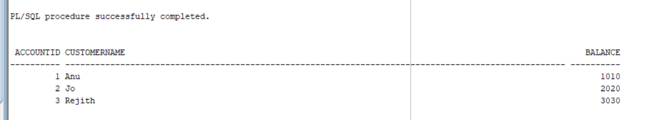

**Scenario 2 :  
CREATE TABLE**

CREATE TABLE Employee (

EmployeeID NUMBER PRIMARY KEY,

Name VARCHAR2(100),

Department VARCHAR2(50),

Salary NUMBER

);

**INSERT VALUES**

INSERT INTO Employee VALUES (1, 'John', 'Sales', 30000);

INSERT INTO Employee VALUES (2, 'Mary', 'IT', 40000);



CREATE OR REPLACE PROCEDURE UpdateEmployeeBonus (

p_department IN VARCHAR2,

p_bonus_percent IN NUMBER

) IS

BEGIN

UPDATE Employee

SET Salary = Salary + (Salary * p_bonus_percent / 100)

WHERE Department = p_department;

COMMIT;

END;

EXEC UpdateEmployeeBonus('Sales', 10);

**OUTPUT**

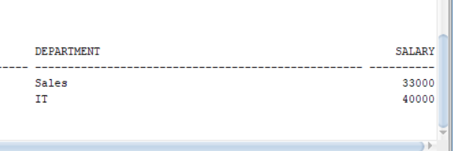

**Scenario 3:**

**Table Creation**

CREATE TABLE BankAccount (

AccountID NUMBER PRIMARY KEY,

CustomerName VARCHAR2(100),

Balance NUMBER

);

**INSERT VALUES**

INSERT INTO BankAccount VALUES (101, 'Anand', 5000);

INSERT INTO BankAccount VALUES (102, 'Charan', 3000);

COMMIT;

Select * from BankAccount;

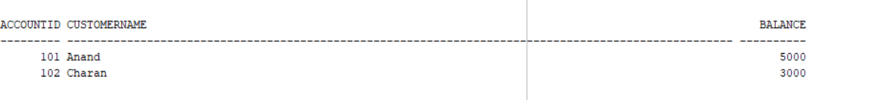

CREATE OR REPLACE PROCEDURE TransferFunds (

p_source_account IN NUMBER,

p_target_account IN NUMBER,

p_amount IN NUMBER

) IS

v_balance NUMBER;

BEGIN

SELECT Balance INTO v_balance FROM BankAccount WHERE AccountID = p_source_account;

IF v_balance < p_amount THEN

RAISE_APPLICATION_ERROR(-20001, 'Insufficient funds in source account.');

END IF;

UPDATE BankAccount

SET Balance = Balance - p_amount

WHERE AccountID = p_source_account;

UPDATE BankAccount

SET Balance = Balance + p_amount

WHERE AccountID = p_target_account;

COMMIT;

END;

EXEC TransferFunds(101, 102, 500);

select * from BankAccount;

**OUTPUT :**

